Civil war in Somalia

UNSC Resolution: | 733
Date of adoption: | 23-Jan-1992
Operative paragraph: | 8
Demand number: | 733,0811

Sarah-Myriam Martin-Brûlé

Wording of demand

take all the necessary measures to ensure the safety of personnel sent to provide humanitarian assistance, assist them in their tasks and ensure full respect for the rules and principles of international law regarding the protection of civilian populations

List of addressees of the demand

Government of Somalia, United Somali Congress Faction

Short-term compliance

Description of the addressee(s)’ conduct

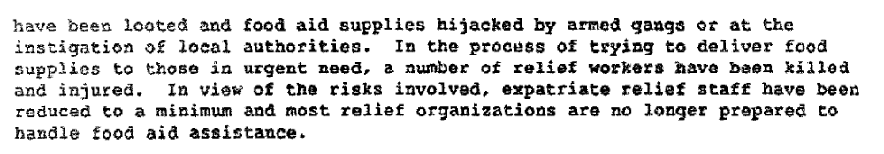

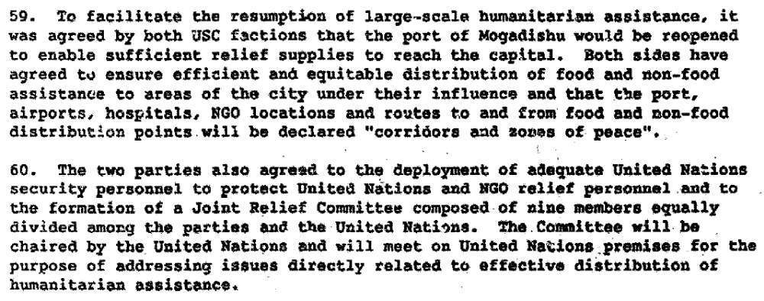

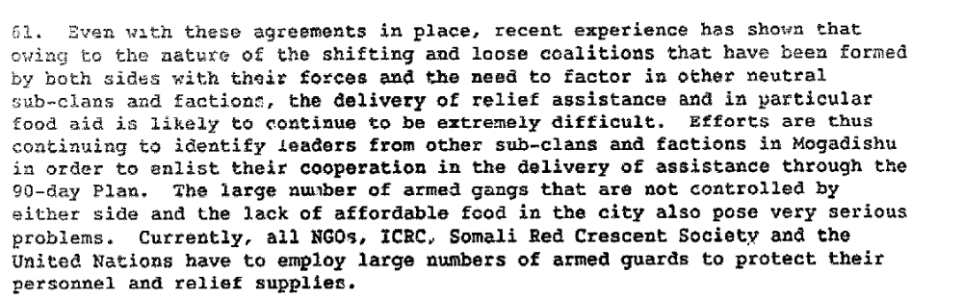

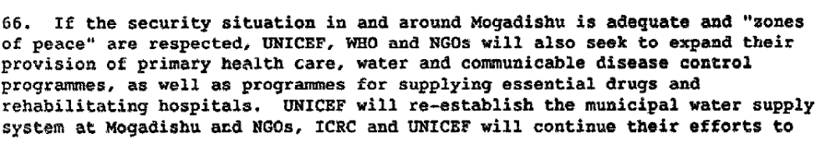
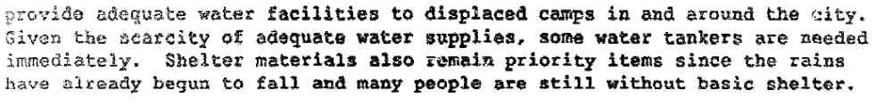

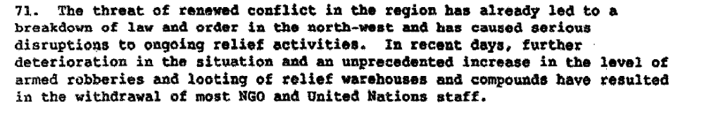

Report of the Secretary General on the Situation in Somalia, 21 April 1992 S/23829/Add.1.

Assessment

Short-term compliance
X No or marginal compliance (1) | Medium low compliance (2) | Medium high compliance (3) | Full or almost full compliance (4)

Considerations underlying the assessment

The parties agreed to this demand yet they did not take all the necessary measures t to control their factions enough to prevent them from violating the agreement.

Medium-term compliance

Description of the addressee(s)’ conduct

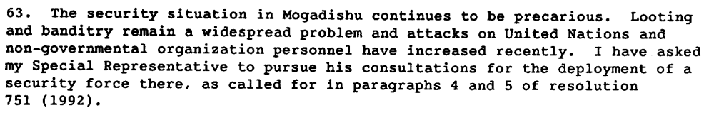
Report of the Secretary General on the Situation in Somalia, 22 July 1992 S/24343/.

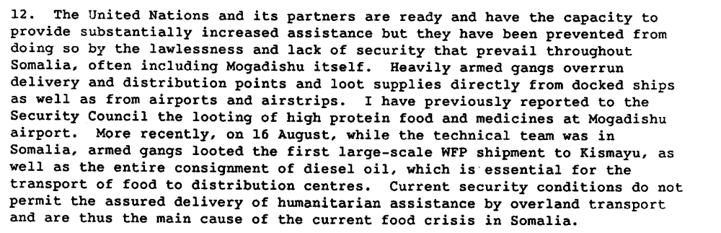
Report of the Secretary General on the Situation in Somalia, 24 August 1992 S/24480/.

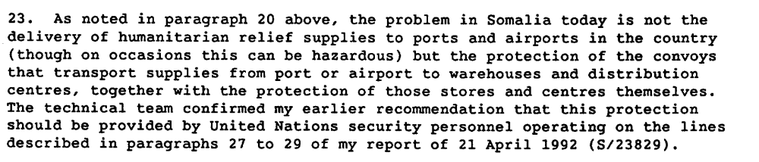
Report of the Secretary General on the Situation in Somalia, 24 August 1992 S/24480/.

By November 1992, the two principal problems in Somalia were perceived at the UN to be famine and weapons. Only a trickle of assistance was getting through as security conditions worsened. Any effort at a political process had ceased. The streets of Mogadishu were dominated by “technicals”, or vehicles on which an automatic weapon had been mounted. UNOSOM observers in Mogadishu were hijacked and robbed by troops loyal to Ali Mahdi. The Pakistani troops finally secured the airport on 10 November, but came under heavy fire from Aidid’s forces. A WFP cargo ship was shelled in the port on 24 November. Relief agencies were paying protection money and bribes to guarantee the safety of their some-400 civilian personnel. The Security Council and the Secretary-General agreed the situation had become “intolerable” and that resort to use of force under Chapter VII to deliver humanitarian assistance should be considered.

the meantime, the territorial extent of UNITAF’s deployment in 40% of the country set a pattern that UNOSOM II never managed to deploy beyond. Despite demands by the Secretary-General to deploy throughout the country, [34] and to address the humanitarian needs and security concerns in the north, Sahnoun’s notion of dividing the entire country into four regions was discarded. Instead, nine Humanitarian Relief Sectors (HRS) were established according to military imperatives dictated by response needs of the famine around Kismayo, Bardera, Oddur, Baidoa, Baledogle, Gialalassi, Belet Uen, Mogadishu and Marka. Mogadishu was chosen as the headquarters because of the size of the port. The only other comparable deep-water port nearby was at Kismayo, but it was not big enough. The net result was to centralize operations again in Mogadishu, with the disadvantages of being caught between the struggle of the two principal warlords, Mahdi and Aidid

Chopra, Jarat. 1995. “Fighting for Hope in Somalia”, Journal of Humanitarian Assistance. February 19th.
http://jha.ac/1995/02/19/fighting-for-hope-in-somalia/

As you know, the Secretary-General has reported to the Security Council
that the political reconciliation process is at an impasse. The result has been a vacuum of civil authority and governmental structure. This has left the United Nations with no basis to underpin its efforts to help Somalia to emerge from the present crisis. Security conditions have continuously deteriorated, especially in Mogadishu, and the tragic toll in lives of peace-keepers and relief workers and Somali personnel has continued to rise. As you are also aware, the date already foreseen for termination of the United Nations peacekeeping mission (UNOSOM) is the end of March 1995. In the absence of adequate Somali cooperation, the assumptions underlying the UNOSOM deployment in Somalia have been fundamentally undermined and so have the prospects of achieving the
United Nations objectives as set out by the Security Council. In these
circumstances, continuation of UNOSOM beyond March 1995 cannot be justified.

REPORT OF THE SECURITY COUNCIL MISSION TO SOMALIA
ON 26 AND 27 OCTOBER 1994S/1994/1245, 3 November 1994
http://www.securitycouncilreport.org/atf/cf/%7B65BFCF9B-6D27-4E9C-8CD3-CF6E4FF96FF9%7D/SC%20Mission%20S%201994%201245.pdf

Perceptions Toward UN Relief Operations. There were varying degrees
of hostility towards the UN and international relief operations across the country
depending on the warring faction occupying the area and its leadership. Ali Mahdi and
his USC was unpredictable but generally supportive of the UN relief efforts.

The antagonist factions were located in the region from south
Mogadisu to the port city of Kismaayo and as far west as Baidoa and Bardera. The
primary protagonist was the SNA faction of the USC led by Mohammed Farrah Hasan
Aideed and Oman Hassan Ali Atto. Aideed and Atto disapproved of any outside
intervention in Somalia. Aideed was a former General in the Barre government with
considerable influence in the powerful Habr Gedir clan who had broken with the nominal
government formed by Ali Mahdi. Aideed was gaining wealth and power from the
country’s ongoing chaos and saw intervening UN forces as a threat to his power base,
maintained by threat and intimidation and the ability to withhold food. Aideed’s allies,
the SNA/Somali Patriotic Movement (SPM) led by Omar Jess and the SPM-Gabio led by
Mohammad Siad Hersi Morgan, occupied the territory to the south of the capital. This
was a primary issue for the UN relief effort, as they occupied the main transportation
hubs in southern Somalia, and therefore, had to be dealt with.

Adversary Situation. Mogadishu was considered a key hub in the
transportation network for relief supplies into Somalia. Most of the relief supplies for
central and southern Somalia, the areas hardest hit by civil strife and famine, pass through
Mogadishu and its seaport and airport. Mogadishu was also the location of the main fault
line between warring factions represented by the SNA (Aideed) on the one side, and the
USC (Ali Mahdi) on the other. Therefore, the situation in Mogadishu for UN
humanitarian relief was critical to the overall operation.

Joint Intelligence Preparation of the Operational Environment, June 16 2009.
http://www.dtic.mil/doctrine/jel/new_pubs/jp2_01_3.pdf

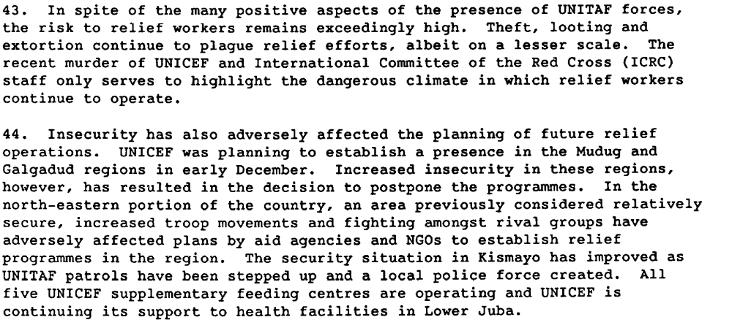

Report of the Secretary General on the Situation in Somalia, 26 January 1993 S/25168/.

Assessment

Medium-term compliance
X No or marginal compliance (1) | Medium low compliance (2) | Medium high compliance (3) | Full or almost full compliance (4)

Considerations underlying the assessment
In the medium term, the parties did not comply with this demand.

Depth of demand

Assessment

Level of depth of demand
Low depth of demand (1) | X Medium depth of demand (2) | High depth of demand (3)

Considerations underlying the assessment
The survival of the parties were not at risk yet the looting fueled their revenues and reinforced their respective control over the population.

Level of confidence about coding decisions

Level of confidence about coding decision
Extremely high | X High | Moderate

Comments to IPI (if any)

